ERGOANALYSIS^{tm} –

participant information

wHAT IS ERGOANALYSIS?

measuring work PHYSICAL loading
Muscle performance can be measured with smart clothing wirelessly regardless of place.
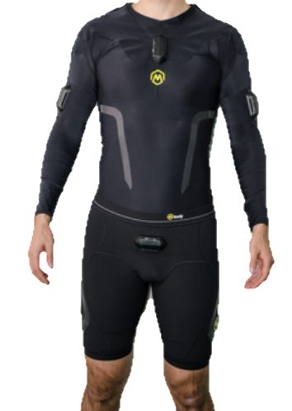

Smart wear collects data about physical loading of overall work physical load, during selected work phases, between different working techniques, or in comparing loading level of different tools or ergonomic solutions.

See you in Munich!

ErgoAnalysisTM measurement protocol
- Before dressing the smart wear, the skin under the sensors will be moisturized with non-fragrant cream and the sensors with water spray. Smart shirts have wireless sensors measuring muscle electrical activity and postures of the upper limbs and trunk. Heart rate is measured via smart watch.
- Prior to the work physical load measurements, a set of short duration (5 sec) maximum isometric muscle tests are performed. These are needed because work physical loading is always assessed as relative (%) load compared to the participant’s own maximal muscle performance level. A short questionnaire of information needed in the data processing will be filled.
- Measurements are done in real working environments and while working normally, with normal protective clothes on. The whole measurement time is video recorded (except break times) to enable synchronizing the measurement data, including the minor work phases, with the other collected data in the analysis.
- The duration of the measurements depends on the purpose of the ErgoAnalysisTM project plan, the usual time is 2-4 hours. Even 8 hours’ measurement time is eligible if needed.
“Myontec’s technology is patented, validated and used by large international corporations”

Data
- The result of the desired work phase is available in Quick Report where the individual or group values are referred to scientific reference values. The Quick Report shows in colours and numbers if the loading level exceeds the recommendations.
- The report gives information about each muscles’ loading level, static loading, micro breaks, as well as heart rate.
- Individual data is strictly confidential if not otherwise agreed. The occupational health personnel may have the data only by the permission of the participant. Anonymous data will be part of large data base for non-commercial occupation specific reference values. See Myontec’s privacy policy at https://www.myontec.com/privacy-policy.
Reducing physical loading prevents work-related musculoskeletal disorders, enhances work fluency and improves worksite safety!

